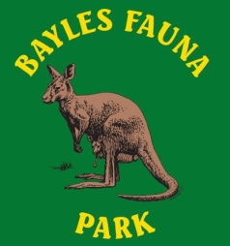
Bayles Fauna Park Inc
19 Conferta Court
Cranbourne West Vic 3977
A0019831L ABN: 35 724 570 017
www.baylesfaunapark.weebly.com

Membership for Bayles Fauna Park Inc
Application for Membership of Bayles Fauna Park Inc.
I, ____________________________________________________________________________
(Full Names of applicant)
Or group name (if applicable) ______________________________________________________
Of ____________________________________________________________________________
(Postal Address)

Telephone Contact Number: _______________________________________________________
Email address: __________________________________________________________________
Desire to become a member of the association for the time being in force.
I am aware that if I use my own property (cars, tools or any type of equipment) in or for the Bayles Fauna Park it is at my own risk. The Bayles Fauna Park Inc. is not responsible or liable for any loss or damage to the said property.
Membership cost is $2.00 per year or part thereof. Membership fee is renewable in August / September each year

Signature of Applicant: _____________________________________Date: _________________

Member Nomination Section
I, _______________________________________(print name of Office bearer of organization) nominate the above person / group for membership of the Bayles Fauna Park Inc.
Signature of Proposer: _____________________________Date: ______________
I, ________________________________ (print name of officer bearer) second the nomination of the above person/group to membership of the Bayles Fauna Park Inc.
Signature of Seconder: ____________________________Date: ______________
Office Use Only______________________________________________________
Paid ___________ Receipt No: ________________ Date: ______________

